Question 2 Notes

Question 2 A
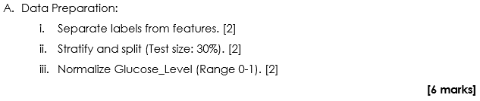
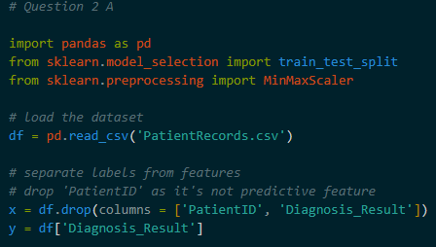
Separating Labels From Features
- Divide the dataset into two variables
- Features (x) : The inputs used for prediction (Age, Glucose_Level, BMI, BloodPressure). The PatientID is removed because it is an identification number and does not contain predictive data
- Label (y) : The target output we want to predict (Diagnosis_Result)

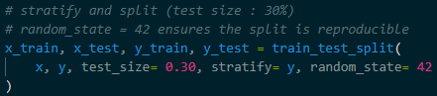
Stratified Data Splitting
- Divide the data into a Training Set (70%) and a Testing Set (30%)
- Stratify : This process maintain the same ratio of Healthy to Diagnosed patients in both sets. This prevents the model from being trained on a biased sample

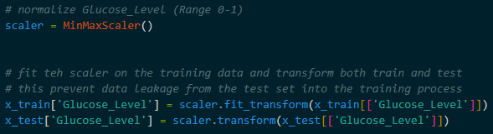
Normalization
- Rescale the Glucose_Level to a range between 0 and 1
- Purpose : Since features like Blood Pressure and Glucose have different numerical scales, normalization ensures that one feature does not outweigh another simply due to the size of it’s numbers

Question 2 B
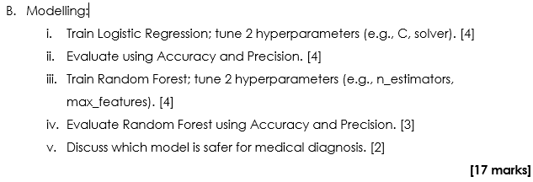
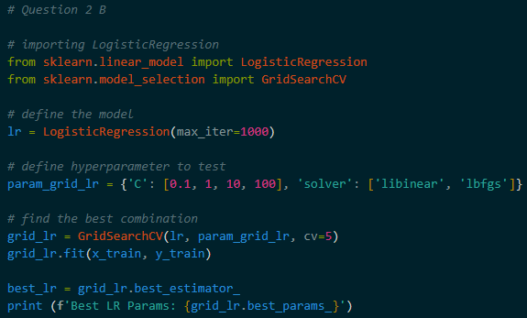
Logistic Regression & Hyperparameter Tuning
- Algorithm :- A linear model used to calculate the probability of a binary outcome (0 or 1)
- Tuning (C & Solver): * C :- Adjusts the strength of regularization to prevent the model from becoming too complex
  - Solver :- The mathematical algorithm is used to find the best-fit line
- Evaluation :- Measured by Accuracy (Total Correct Predictions) and Precision (The Percentage of Positive Identifications that were actually correct)

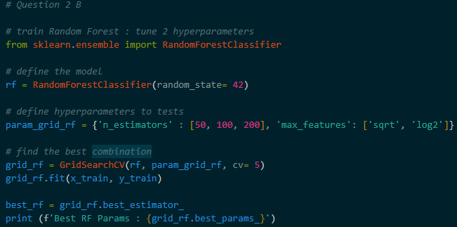
Random Forests & Hyperparameter Tuning
- Algorithm :- An ensemble model that creates many decision trees and combines their results to improve accuracy
- Tuning (n_estimators & max_features):
  - n_estimators : The number of decision trees In the forest
  - max_features : The maximum number of columns the model looks at when splitting a tree
- Evaluation : Similar to the first model, checking Accuracy and Precision to see how the forest performed compared to the linear model

Sources
Scikit-Learn Documentation (2024). train_test_split. https://scikit-learn.org/stable/modules/generated/sklearn.model_selection.train_test_split.html
Qubahan Academic Journal (2023). A New Preprocessing Method for Diabetes and Biomedical Data Classification. https://journal.qubahan.com/index.php/qaj/article/download/135/73/768
OCCaM Machine Learning (2024). Tuning Hyperparameters. http://occam.olin.edu/sites/default/files/DataScienceMaterials/machine_learning_lecture_2/Machine%20Learning%20Lecture%202.html
The Public Health AI Handbook (2024). Machine Learning Fundamentals. https://publichealthaihandbook.com/foundations/ai-basics.html

